For this homework we'll be creating a visualization dashboard website using visualizations we've created in a past assignment. Specifically, we'll be plotting weather data.

In building this dashboard, we'll create individual pages for each plot and a means by which we can navigate between them. These pages will contain the visualizations and their corresponding explanations. We'll also have a landing page, a page where we can see a comparison of all the plots, and another page where we can view the data used to build them.

The website requirements will consist of 7 pages total including:

1. Landing page containing:
   1. An explanation of the project
   2. Links to each visualization page

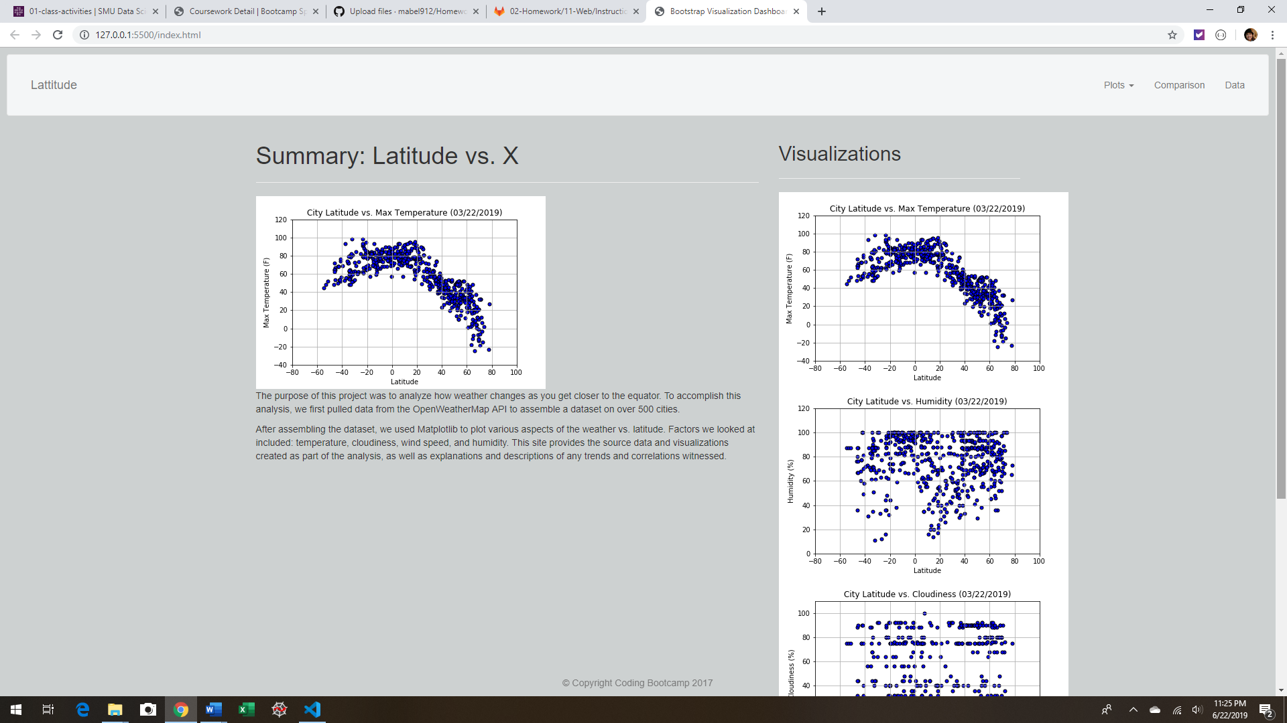

1. Four visualization pages each with:
   1. A descriptive title and heading tag
   2. The plot/visualization itself for the selected comparison
   3. A paragraph describing the plot and its significance

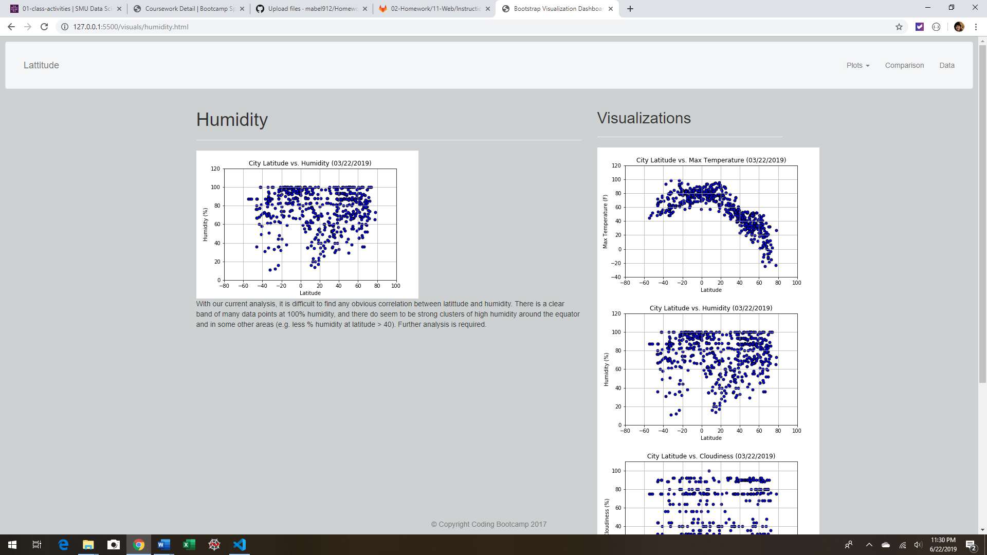

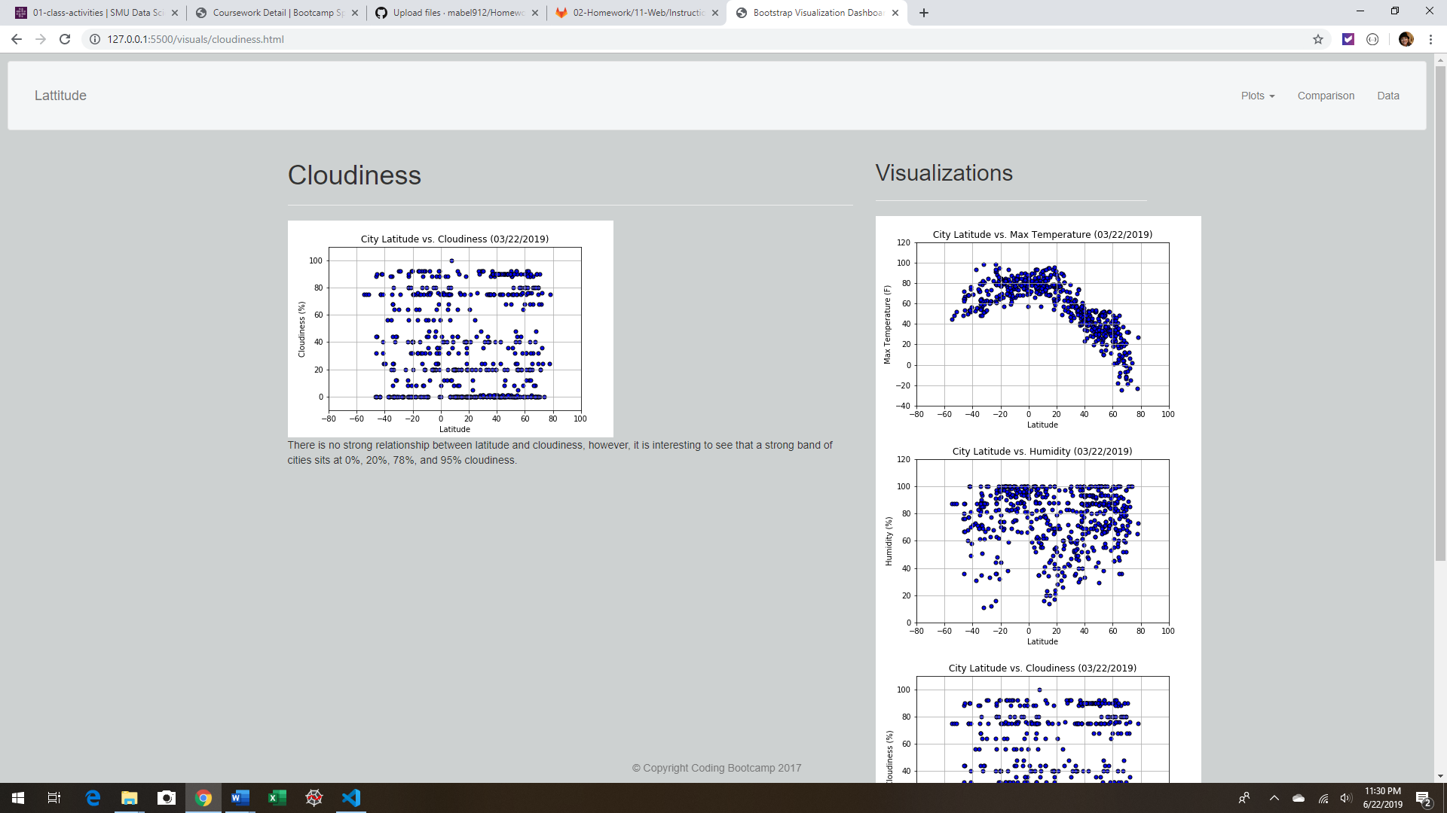

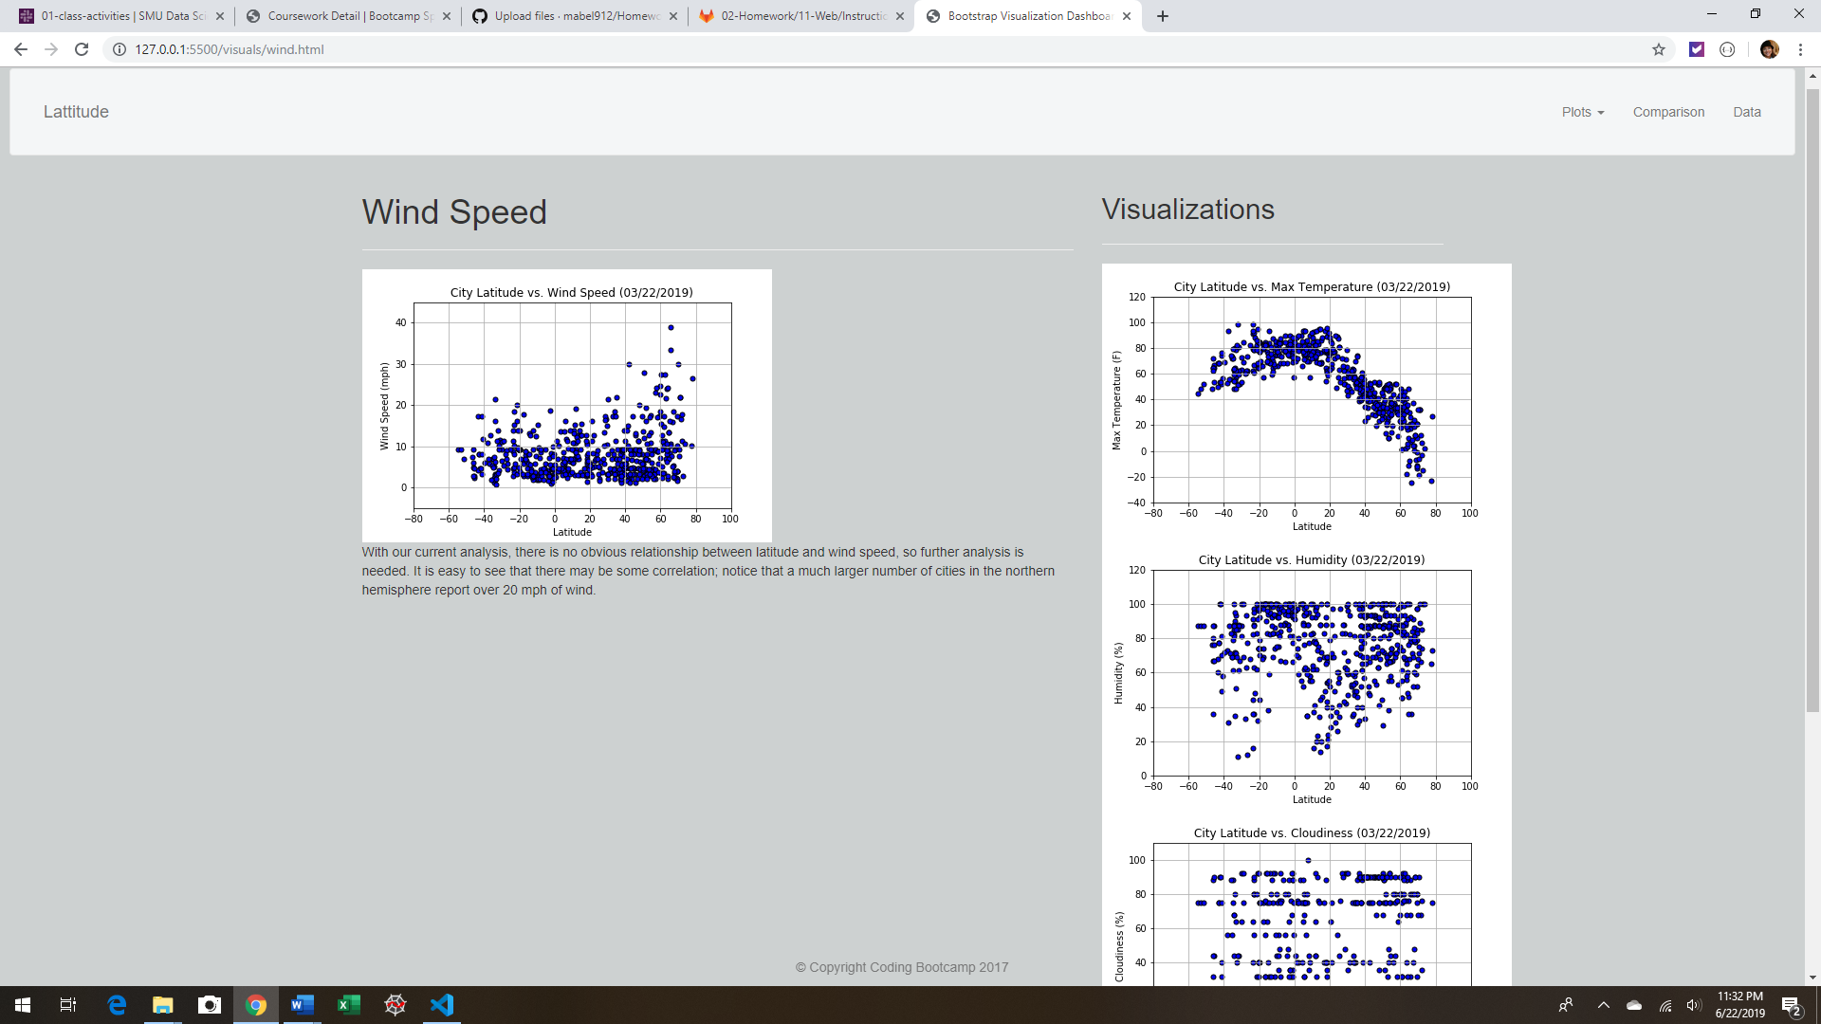

1. Comparisons page that:
   1. Contains all the visualizations on the same page so we can easily visually compare them
   2. Uses a bootstrap grid for the visualizations
   3. The grid must be two visualizations across on screens medium and larger, and 1 across on extra-small and small screens

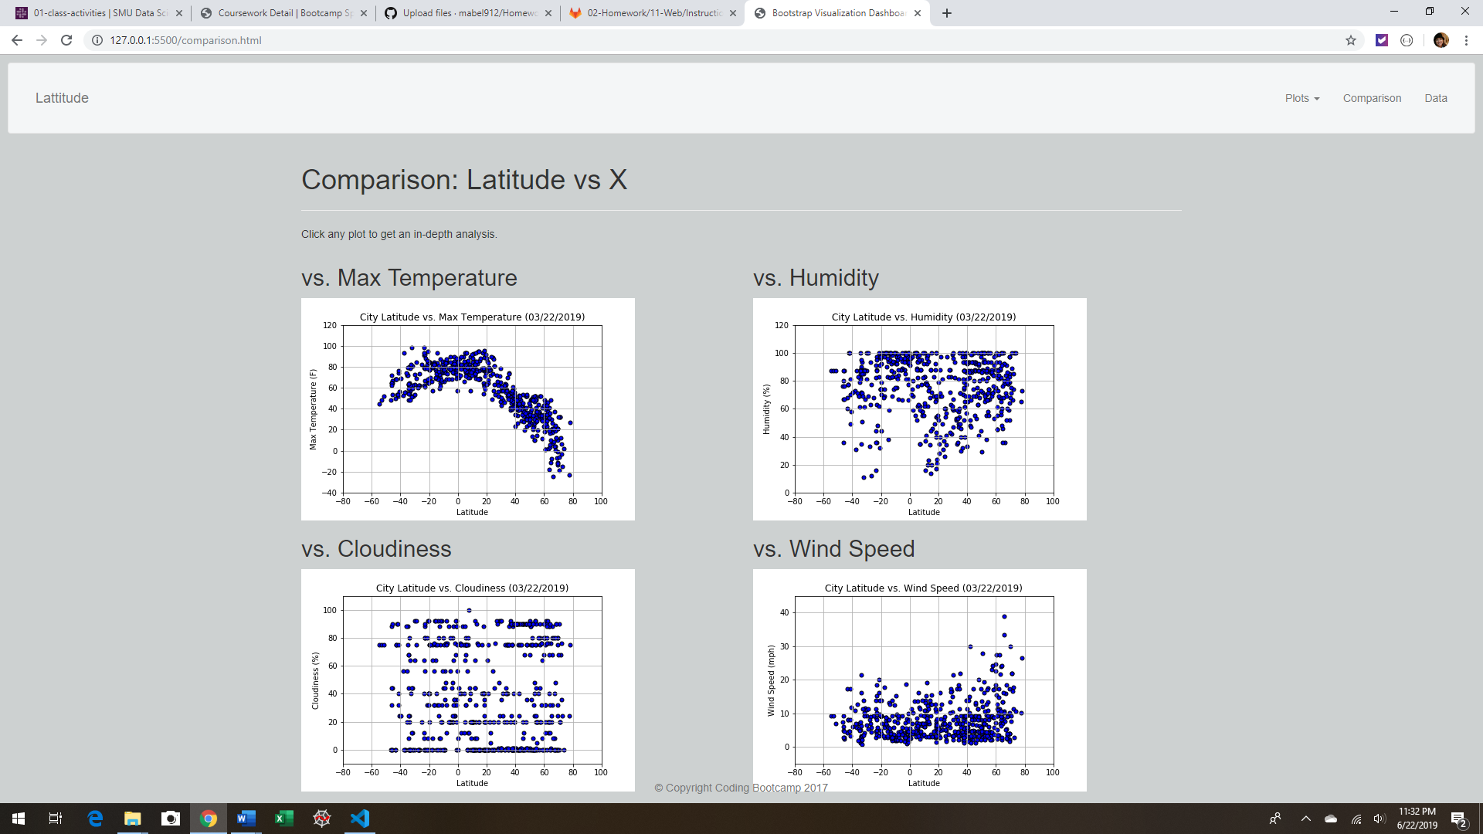

1. Data page that:
   1. Displays a responsive table containing the data used in the visualizations
   2. The table must be a bootstrap table component
   3. The data must come from exporting the .csv file as HTML, or converting it to HMTL. Or you can use a csv-to-html table conversion tool, e.g. ConvertCSV.

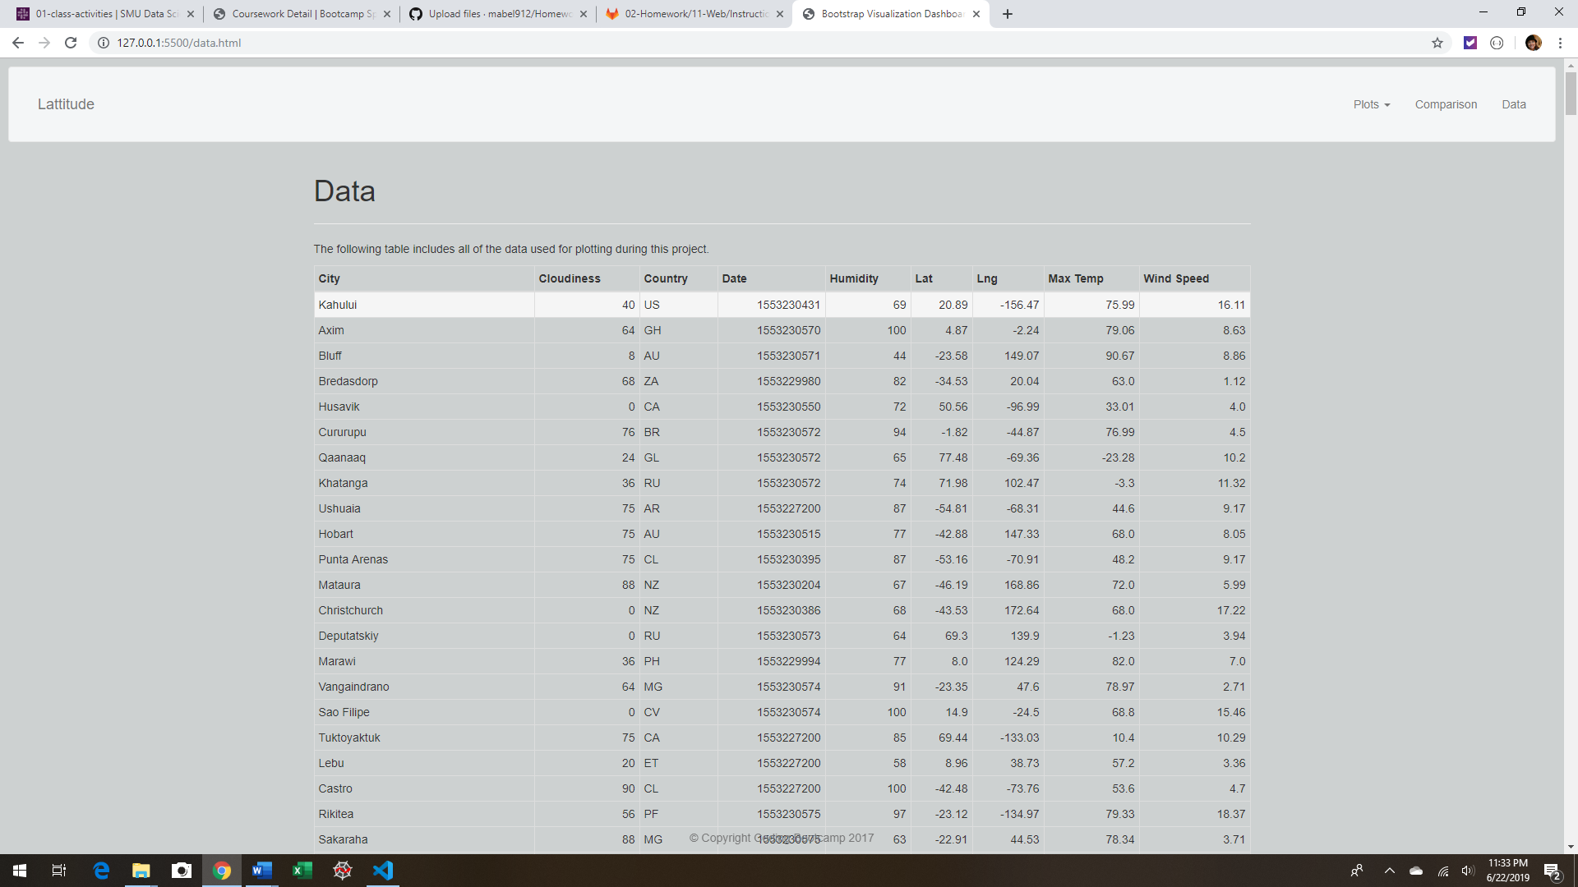

The website must, at the top of every page, have a navigation menu that:

* Has the name of the site on the left of the nav which allows users to return to the landing page from any page.
* Contains a dropdown on the right of the navbar named "Plots" which provides links to each individual visualization page.
* Provides two more links on the right: "Comparisons" which links to the comparisons page, and "Data" which links to the data page.
* Is responsive (using media queries). The nav must have similar behavior as the screenshots "Navigation Menu" section (notice the background color change).

Finally, the website must be deployed to GitHub pages.

When finished, submit to BootcampSpot the links to 1) the deployed app and 2) the GitHub repository.